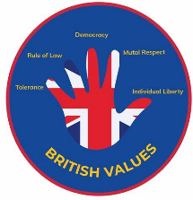
KS3 Thematic Curriculum - Pathway 1 and 2

Cycle A | Term1 | Term2 | Term3 | Term 4 | Term 5 | Term 6
Theme | Me, Myself + My Body   | Winter Warmer   | Charity Champions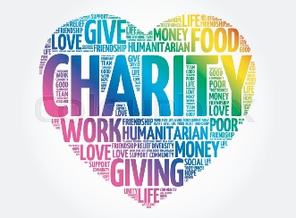 | Help! Public Services 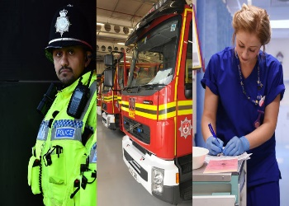 | Market Town Towcester  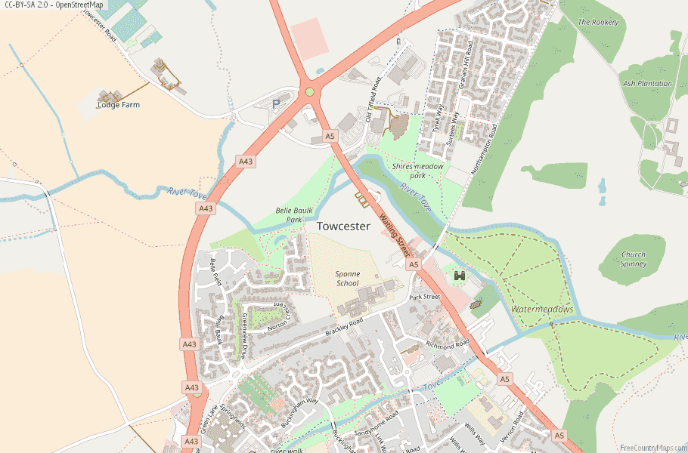 | Great Britain 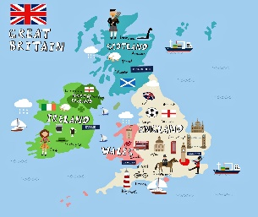
Core Curriculum Subjects | Mathematics;: See long term plan – White Rose Maths
Core Curriculum Subjects | English, phonics, and communication: See long term plans – Read, Write Inc
Subject Centred Curriculum | Creative Arts  Portraits  Master Techniques in Drawing  Paper  Master Practical Skills in Using Materials | Creative Arts  Winter Collage  Master Techniques in Collage  Weaving  Mastering Practical Skills in Textiles | Creative Arts  Sculpture  Master Techniques in Sculpture  Master Practical Skills in Construction and Mechanics | Creative Arts  Famous Artists  Master Techniques in Painting  Upcycling  Master Practical Skills in Textiles | Creative Arts  Natural Materials  Master Techniques in Printing  Food Prep  Mastering skills in Food Preparations | Creative Arts  Pop Art  Master Techniques in Drawing  Design  Make, Evaluate and Improve
Subject Centred Curriculum | Scientific Technologies  Healthy Humans  The human body | Scientific Technologies  Everyday Materials Comparing and testing | Scientific Technologies Plants  Growing | Scientific Technologies  Light | Scientific Technologies  Sound | Scientific Technologies  Forces
Subject Centred Curriculum | Computing Technology and Inclusivity  Computing devices, systems and networks |  | Computing Technology and Inclusivity  Creating Media |  | Computing Technology and Inclusivity  Data
Subject Centred Curriculum | Food Technology  Food a Fact of Life: Healthy Eating – Eat Well  Fruits and Vegetables |  | Food Technology  Food a Fact of Life: Food Hygiene and Safety |  | Food Technology  Food a Fact of Life: Food Origins
Subject Centred Curriculum | Geography | Geography | Geography  Compare Locations Overseas  Investigating Places | Geography | Geography  Local Environment  Communicate Geographically | Geography  Natural and Manmade  Investigate Pattern
Subject Centred Curriculum | History  Understanding Chronology –  Past, present, future | History  Connections in the World | History | History  Investigate and Interpret Evidence | History | History
Subject Centred Curriculum | PSHE/RSE -PSHE Association  Self-Awareness | PSHE/RSE – PSHE Association  Self-Care, Support and Safety | PSHE/RSE – PSHE Association  Managing Feelings | PSHE/RSE – PSHE Association  Changing and Growing | PSHE/RSE – PSHE Association  Healthy Lifestyles | PSHE/RSE – PSHE Association  The World I Live In
Subject Centred Curriculum | Music –Charanga | Music – Charanga | Music – Charanga | Music – Charanga | Music – Charanga | Music – Charanga
Subject Centred Curriculum | Movement and Physical Education  Gymnastics | Movement and Physical Education  Games: Tennis | Movement and Physical Education  Dance | Movement and Physical Education  Net Games | Movement and Physical Education  Gymnastics | Movement and Physical Education  Games
Careers and Enterprise | Careers  GB1 | Enterprise: Christmas Fayre | Careers  GB3 | Enterprise: Easter Fayre | Careers  GB4 | Enterprise: Summer Fayre
My Community (Trips and Enrichment) |  |  | Visit a local charity (preferably the one we donated to at Christmas) | Visit local public service centres | Towcester Country Park | Agree a special day out as a class somewhere in Britain
Department/ Whole School Opportunities | Celebrating differences in our favourite things (class/department based) | Christmas productions  Backwards Christmas Calendar | Stay and play |  |  | Sports Day  KS3 Big Sing
Cultural capital and RE | Unit 7.1: What is religion? What counts as knowledge?  Diwali Festival of Lights | Unit 7.2: How important was it that Jesus was human?  Christianity at Christmas | Unit 7.3: Animal Rights: Do we have the right to exploit animals?  World Religion Day – to be celebrated on 19th January 2026 | Unit 7.4: Is Hindu Dharma a monotheistic or polytheistic religion?  Faith Day (Eid) | Unit 7.5: Who is Buddhist and how do they account for suffering in the world? | Unit 7.6: Is causing conflict ever justified?
Religious education and cultural capital will be explored through the schools broad and balanced curriculum themes, PSHE/RE, preparation for adulthood curriculum and assemblies.

The school will use and adapt West Northamptonshire’s agree Religious Education syllabus ‘ Growing Together’. The above unit refers to the syllabuses recommended units throughout all key stages. Recommended activities can be found within the syllabus document here: 7eb13e23e7c8b48722a49cdbc718a14b735664dddf936aa1a4c4a1d6bf53.pdf

Staff should consider these in their planning. There are many recommended continuous provision activities and questions to be explored that can help support learners and their religious education and understanding.

Tiffield will participate in national schemes such as world religion day and Inter Faith weeks, where it is deemed appropriate and accessible to learners

