
KS2 Long Term Plan - CYCLE A

Term | Term1 | Term2 | Term3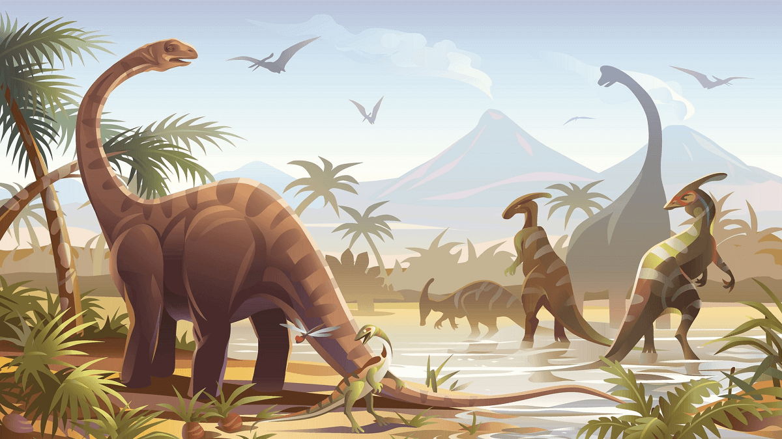 | Term 4  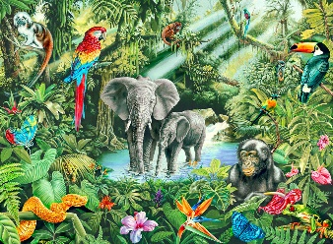 | Term 5 | 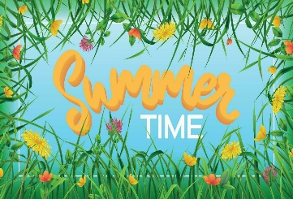  Term 6
Theme | Theme: Wonderful Me | Theme: Winter Wonderland | Theme: Dino Discovery! | Theme: Rainforest | Theme: April Showers, May Flowers | Theme: British Summer Time
Sequential Curriculum Subjects | Mathematics  See long term plan – White Rose Maths | Mathematics  WRM | Mathematics  WRM | Mathematics  WRM | Mathematics  WRM | Mathematics  WRM
Sequential Curriculum Subjects | Literacy:  Writing, Reading, and communication & Interaction  See long term plans – Read, Write Inc | Literacy:  Writing, Reading, and communication & Interaction  See long term plans – Read, Write Inc | Literacy:  Writing, Reading, and communication & Interaction  See long term plans – Read, Write Inc | Literacy:  Writing, Reading, and communication & Interaction  See long term plans – Read, Write Inc | Literacy:  Writing, Reading, and communication & Interaction  See long term plans – Read, Write Inc | Literacy:  Writing, Reading, and communication & Interaction  See long term plans – Read, Write Inc
Recommended Texts | From Head to Toe All Kinds of People  My Five Senses  W is for World – Oxfam  FunnyBones Eyes that Speak to the Stars | Polar Bear, Polar Bear What do you Hear? The Gruffalo’s Child  The Snowman / The Snow dog  The Polar Express  The Mitten | Dinosaur Rumpus Tyrannosaurus Drip  How to Look After Your Dinosaur  The Dinosaur that Pooped  That’s Not My Dinosaur  Harry and the Bucket Full of Dinosaurs  Dinosaur World Usborne Reader | Slowly, slowly, slowly said the Sloth.  Amazon Rainforest: A Guide in Rhyme  Rainforests Usborne Reader  The Tiger That Came for Tea  My Mum and Dad Make me Laugh  Pablo at the Zoo | Twitch  The Tiny Seed  The Little Red Hen  Therea Tiger in the Garden  The Enormous Turnip  Planting a Rainbow  The Hungry Caterpillar  Handa’s Hen  Peter Rabbit Easter Bunny Junt  Thats my Flower | Puzzle  Summer Adventure Stories Enid Burton  What the Ladybird Heard on Holiday  Hello Summer  One Little Bee Usborne Reader  Things to Spot in Summer Usborne Reader  The Great Kapok Tree  Monkey
Thematic Subjects | Creative Arts  Drawing  Lines and Shapes  Construction  Tools and Techniques | Creative Arts  Collage  Creating Textures  Textiles  Design | Creative Arts  Sculpture  Using Tools and Techniques  Construction  Various Resources | Creative Arts  Printing  Techniques  Natural Materials  Assembly | Creative Arts  Painting  Brush Strokes  Food  Using of Tools | Creative Arts  Drawing  Control  Modelling  Wheels and Pulleys
Thematic Subjects | Scientific Technologies  Animals Including Humans Body Parts – Bones and Organs | Scientific Technologies  Everyday Materials  Similarities and Differences | Scientific Technologies Animals and their habitats  Animal (dinosaur) diets  Rocks and Soil  Digging for bones/fossils | Scientific Technologies Animals  Describing/Grouping and Sorting | Scientific Technologies Plants  Identifying and Naming Common Plants | Scientific Technologies  Forces  Levers, Pulleys, and Gears  Magnets
Thematic Subjects | Computing Technology – See Teach Computing LTP | Computing Technology – See Teach Computing LTP | Computing Technology – See Teach Computing LTP | Computing Technology – See Teach Computing LTP | Computing Technology – See Teach Computing LTP | Computing Technology – See Teach Computing LTP | =
Thematic Subjects | History  Past, present, future  From birth to now | Geography  Seasons and Weather  Climate Change | History  Prehistoric Life  Significant individuals: Mary Anning | Geography  Environments around the world | Geography  Growing in the local environment | History  British History  Monarchy
Thematic Subjects | Food Technology  Healthy Eating | Food Technology  Cooking | Food Technology  Where Food Comes From | Food Technology  Cooking | Food Technology  Healthy Eating | Food Technology  Where Food Comes From
Subject Centred Curriculum | PSHE/RSE -PSHE Association  Self-Awareness – Playing and Working Together | PSHE/RSE – PSHE Association  Self-Care, Support and Safety – Keeping Safe | PSHE/RSE – PSHE Association  Managing Feelings – Manging Strong Feelings | PSHE/RSE – PSHE Association  Healthy Lifestyles – Keeping Well | PSHE/RSE – PSHE Association  Changing and Growing – Interoception | PSHE/RSE – PSHE Association  The World I Live In – Rules and Law
Subject Centred Curriculum | Music –Charanga  Anyone Can Play  Unit 19  Playing Quietly | Music – Charanga  Anyone Can Play  Unit 20  Using Cue Cards | Music – Charanga  Anyone Can Play  Unit 21  Composition | Music – Charanga  Anyone Can Play  Unit 23  Pulse | Music – Charanga  Anyone Can Play  Unit 22  Patterns | Music – Charanga  Anyone Can Play  Unit24  Pitch
Subject Centred Curriculum | Movement and Physical Education  Games Ball Skills | Movement and Physical Education  Gymnastics Travelling, directions and balance | Movement and Physical Education  Dance Movement Patterns Linking Movement | Movement and Physical Education  Gymnastics Apparatus | Movement and Physical Education  Games Net and Wall Games | Movement and Physical Education  Games  Striking and Fielding  Games
Trips and Enrichment |  | Santa Visit | Oxford University Natural Science Museum |  | External Welly Walk | Stanwick Lakes – beach
Department/ Whole School Opportunities | Celebrating differences in our favourite things (class/department based) | Christmas productions  Backwards Christmas Calendar | Stay and play  KS2 Big Dig | Bird Man | Welly Walk/Forest School | Sports Day  Summer clothes mufti day
Cultural capital and RE | Unit 3.1: Diversity within Hindu Dharma: What do Hindus believe and how may they live??  Diwali Celebrations of Lights | Unit 3.2: How and Why are people welcomed into different communities?  Christianity at Christmas | Unit 3.3: Diversity within Hindu Dharma: What do Hindus believe and how may they live?  World Religion Day – to be celebrated on 19th January 2026 | Unit 3.5: What do Jews learn about Passover? What special things might they do | Unit 3.4: Why is Jesus a special person to some religious people? How might this help Christians  lead a good life?  Faith Day (Eid) | Unit 3.6: How do beliefs and ideas about land shape the way human beings live?

