
EYFS Long Term Plan - CYCLE A
 | Term 1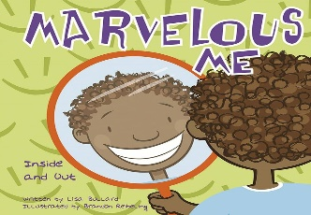 | Term 2 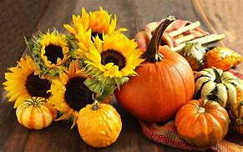 | Term 3 | Term 4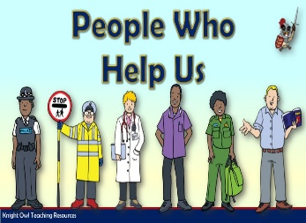 | Term 5 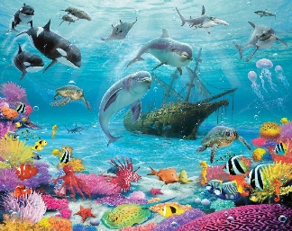 | Term 6 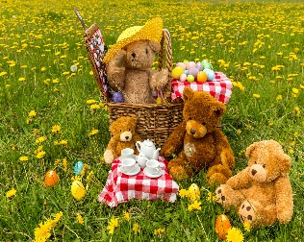
Theme | Theme: Marvellous Me and My Senses. | Theme: Autumn Harvest | Theme: Winter | Theme: People who help us | Theme: Under the Sea | Theme: Teddy Bears Picnic
Early Years Foundation Stage Areas of learning | Communication and Interaction –  PLG  Themed vocabulary  Colourful Semantics-Who | Communication and Interaction –  PLG  Themed vocabulary  Colourful Semantics-Who | Communication and Interaction –  PLG  Themed vocabulary  Colourful Semantics-What | Communication and Interaction –  PLG  Themed vocabulary  Colourful Semantics-What | Communication and Interaction –  PLG  Themed vocabulary  Colourful Semantics-Where | Communication and Interaction –  PLG  Themed vocabulary  Colourful Semantics-Where
Early Years Foundation Stage Areas of learning | Literacy: Reading & phonics  See long term plans – Read, Write Inc  Stories  Nursery Program  Non-fiction  Rhymes  Poems | Literacy: Reading & phonics  See long term plans – Read, Write Inc  Stories  Nursery Program  Non-fiction  Rhymes  Poems | Literacy: Reading & phonics  See long term plans – Read, Write Inc  Stories  Nursery Program  Non-fiction  Rhymes  Poems | Literacy: Reading & phonics  See long term plans – Read, Write Inc  Stories  Nursery Program  Non-fiction  Rhymes  Poems | Literacy: Reading & phonics  See long term plans – Read, Write Inc  Stories  Nursery Program  Non-fiction  Rhymes  Poems | Literacy: Reading & phonics  See long term plans – Read, Write Inc  Stories  Nursery Program  Non-fiction  Rhymes  Poems
Early Years Foundation Stage Areas of learning | Recommended Texts  Marvellous Me, Inside and Out In my heart  Nursery Rhymes/ Rhyming words  Hug  Spreading my wings (C&D)  I love me (C&D)  Lion inside | Recommended Texts  The Tiny Seed  Pumpkin Soup  A walk in Autumn  Autumn Allen Busby  The Enormous Turnip  Room on the Broom | Recommended Texts | Recommended Texts  Busy People Police Officer  Busy People Fire Fighter  Busy People Doctor  Busy People Teacher  Smartest Giant in Town  People need people  When I grow up | Recommended Texts  Commotion in the Ocean  That’s not my Turtle  Tip Tap went the Crab  Sharing a Shell  Tiddler  Rainbow Fish  Blob fish  The Whale who wanted more | Recommended Texts  We are going on a picnic  Where’s Teddy  We’re Going to a Birthday Party  The Teddy Bears Picnic  Goldilocks and the Three Bears  Brown, Brown Bear  Were going on a bear hunt
Early Years Foundation Stage Areas of learning | Literacy: Writing  See Long term plan  Mark making  Dough Disco  Fine Motor Activities | Literacy: Writing  See Long term plan  Mark making  Dough Disco  Fine Motor Activities  Pumpkin Carving  Pushing pins  Communication board | Literacy: Writing  See Long term plan  Mark making  Dough Disco  Fine Motor Activities  Handwriting village- RWI  Colourful Semantics  Communication board  Requesting | Literacy: Writing  See Long term plan  Mark making  Dough Disco  Fine Motor Activities  Handwriting village- RWI  Drawing symbols  Requesting  Sequencing  Role play | Literacy: Writing  See Long term plan  Mark making  Dough Disco  Fine Motor Activities  Handwriting village- RWI  Drawing symbols  Requesting  Sequencing  Tracing & Copying | Literacy: Writing  See Long term plan  Mark making  Dough Disco  Fine Motor Activities  Handwriting village- RWI  Tracing & Copying  Role Play
Early Years Foundation Stage Areas of learning | Mathematics  See long term plan – White Rose Maths | Mathematics  See long term plan – White Rose Maths | Mathematics  See long term plan – White Rose Maths | Mathematics  See long term plan – White Rose Maths | Mathematics  See long term plan – White Rose Maths | Mathematics  See long term plan – White Rose Maths
Early Years Foundation Stage Areas of learning | PSED  Sense of Self  My Family | PSED  Recognising and celebrating differences in people | PSED  Friendships  Sharing | PSE  Asking for help | PSED  Being Safe | PSED  Healthy Eating
Early Years Foundation Stage Areas of learning | Physical Development  Games  Ball Skills: Throwing, catching,  Fine and Gross Motor Skills: Dough Disco | Physical Development  Gymnastics  Balance  Coordination  Fine and Gross Motor Skills: Dough Disco  Interoception | Physical Development  Dance  Developing basic movement skills  Fine and Gross Motor Skills: Dough Disco  Interoception | Physical Development  Games  Ball Skills: Aiming, kicking, passing  Fine and Gross Motor Skills: Dough Disco  Interoception | Physical Development  Gymnastics  Fine and Gross Motor Skills: Dough Disco  Interoception | Physical Development  Dance  Establishing rhyme and timing  Fine and Gross Motor Skills: Dough Disco  Interoception
Early Years Foundation Stage Areas of learning | Understanding the World  My Senses *Interoception  All about me | Understanding the World  The Natural World  Seasons | Understanding the World  Toys Then and Now  Old and New | Understanding the World  People who help me | Understanding the World  Protecting our oceans - recycling | Understanding the World  My community
Early Years Foundation Stage Areas of learning | Expressive Arts and Design  Materials Inside  Music - Charanga  Anyone Can Play  Unit 1  Introducing Instruments | Expressive Arts and Design  Mark Making  Music – Charanga  Anyone Can Play  Unit 2  Exploring Instruments | Expressive Arts and Design  Colour  Music – Charanga  Anyone Can Play  Unit 3  Choosing Instruments | Expressive Arts and Design  Materials Outside  Music – Charanga  Anyone Can Play  Unit 4  Introducing Sway | Expressive Arts and Design  Mark Making  Music – Charanga  Anyone Can Play  Unit 5  Introducing March | Expressive Arts and Design  Colour mixing  Music – Charanga  Anyone Can Play  Unit 6  Introducing Loud and Quiet
Trips and Enrichment | My home  My school | Visit Santa’s Wonderland  Mini bus season’s drive |  |  | Visit local fish/Pets at home | Attend a local park for a picnic
Department/ Whole School Opportunities | Celebrating differences in our favourite things (class/department based) | Harvest Festival  Christmas productions  Backwards Christmas Calendar | Stay and play | Public service vehicle visit  Dress up as someone who helps us/you
Cultural capital and RE | Unit 0.1: What special times do we celebrate?  Diwali Celebrations of Lights | Unit 0.2: Why is the nativity story important to Christians?  Christianity at  Christmas – visit a local Christmas church/service | Unit 0.3: Where do we belong and what makes it special?  World Religion Day – to be celebrated on 19th January 2026 | Unit 0.5: Why is Easter an important time for Christians and what special things to they do at Easter?  Faith Day (Eid) | Unit 0.4: What stories are special and why? | Unit 0.6: What is special about the world?
Cultural capital and RE | Religious education and cultural capital will be explored through the schools broad and balanced curriculum themes, PSHE/RE, preparation for adulthood curriculum and assemblies.  The school will use and adapt West Northamptonshire’s agree Religious Education syllabus ‘ Growing Together’. The above unit refers to the syllabuses recommended units throughout all key stages. Recommended activities can be found within the syllabus document here: 7eb13e23e7c8b48722a49cdbc718a14b735664dddf936aa1a4c4a1d6bf53.pdf Staff should consider these in their planning. There are many recommended continuous provision activities that can help support learners and their religious education and understanding.  Tiffield will participate in national schemes such as world religion day and Inter Faith weeks, where it is deemed appropriate and accessible to learners.

Notes page

